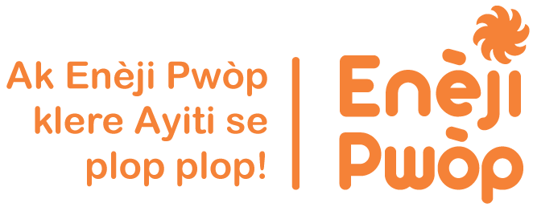

EarthSpark Launches ‘Town-sized, Solar-Powered, Smart Grid’ to Deliver Electricity in Rural Haiti

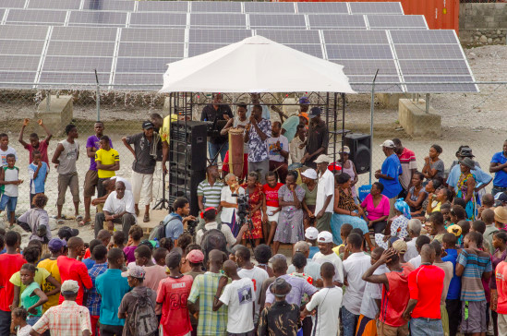

Washington DC—June 9, 2015 – On June 1, 2015, EarthSpark International inaugurated the EKo Pwòp micro-grid which provides clean, reliable power to 430 homes and businesses in downtown Les Anglais in the South of Haiti. The newly installed grid is powered by a state-of-the-art hybrid generation system, which includes a 93kW solar PV array, 450 kWh of battery capacity, and a small diesel backup generator. The system is also serviced by SparkMeter smart meters which enable customers to pre-pay for electricity and shift load limits, a ‘smart’ system that facilitates metering and billing and enables a more efficient grid operations. Over the period of building the Les Anglais grid, EarthSpark spun off SparkMeter, Inc. into a company that is now commercializing smart meters for grid operators in developing markets around the world. With 75% of the population of Haiti currently lacking electricity access, this town-sized, solar-powered, smart grid is providing residents and businesses in Les Anglais with clean, affordable, reliable electricity from a grid that can serve as a model to be refined and replicated in other rural towns across the country.

To further highlight the launch of the grid and those who made it possible, EarthSpark will host a ‘Spark Soirée’ fundraiser and celebration on Thursday, June 11 from 6 to 9 PM in Washington, DC. EarthSpark invites friends and supporters to join the team at the National Grange Building, 1616 H St. NW, and to please RSVP to Ms. Alex Fisher at alex@earthsparkinternational.org.

EarthSpark’s initial grid development began in 2012 with initial funding from Naitonal Geographic and from the Government of Norway through the UN and Coalition partners "Côte Sud Initiative (CSI). Through a partnership with Digicel, Haiti’s largest telecommunications company, EarthSpark was able to tap into underutilized capacity from the generator powering the telecommunications tower in Les Anglais to serve its initial customers who had previously relied on expensive kerosene lamps and diesel generators for lighting and electricity.

Now the grid is powered by sunshine. The construction of the solar hybrid generation system and the expansion of service from 54 to 430 customers was made possible by a United States Agency for International Development grant from Powering Agriculture: An Energy Grand Challenge for Development. Powering Agriculture supports sustainable approaches to accelerate the development and deployment of clean energy solutions for increasing agricultural productivity and value in developing countries. With over half of the downtown residents of Les Anglais working in the agricultural sector, EarthSpark is working with local agricultural entrepreneurs to ensure that increased electricity access translates into sustainable economic development.

Additional funding came from Linkin Park’s Power the World campaign, the 11th Hour Project, the United Nations Foundation, and individual donors.

EarthSpark will use the Les Anglais project as a model for the installation of future grids in Haiti. On May 21, 2015, at the United Nations Sustainable Energy for All Forum, EarthSpark and its Haitian social enterprise spin-off, Enèji Pwòp, S.A. announced a joint commitment to build 80 micro-grids in Haiti by the end of 2020.

The grid is a product of many partnerships. Haiti’s Ministry of Public Works provided a letter of support for the grid before its initial launch. Speaking from the small stage at the grid inauguration last week, M. Marc André Chrysostom, Energy Coordinator for the Ministry, observed, "This solar hybrid grid is the first of its kind in Haiti. It is a very good model and should serve as a pilot to allow Haitian students and technicians to strengthen their capacities for rural electrification and microgrid." Senators, Deputies, Mayors, and representatives from Haitian academia all played important roles. The generation system was designed and installed by ZeroBase Energy, LLC, a Michigan-based firm. The distribution system was designed and installed by GEMSA, a Dominican firm. Volunteers from the National Rural Electric Cooperative Association and specifically Shelby Electric Coop helped to install the pilot grid’s wiring.

More photos from the inauguration are available here. EarthSpark is running a small fundraising campaign to pay for media and editing of film footage from the event to share across Haiti.

EarthSpark International is a non-profit 501(c)3 organization working as an incubator for clean energy enterprises that can deliver sustainable energy services in off-grid Haiti. EarthSpark is bringing together technology, business models, and community engagement to deliver clean, reliable, and affordable energy that is unlocking wealth and opportunities in rural Haitian towns. For more information visit www.earthsparkinternational.org

Enèji Pwòp, S.A. is a Haitian social enterprise launched in 2014 as a spin-off of EarthSpark International. It works closely with its non-profit parent organization and with local Haitian entrepreneurs and community leaders to increase access to clean and efficient energy products and services in underserved areas of Haiti. Enèji Pwòp has been involved in the development of EarthSpark’s micro-grid in Les Anglais, and took over operations and management of the grid in May 2015. For more information visit www.enejipwop.com.

